Final Report

**Group A13:**   
Erik Reimer, Christian Tverås, Stefan Bui  
Jonas Foyn Therkelsen, Julie Johnsen Kirkhus

**Chosen COTS:** Android Application

**Primary Quality Attribute:** modifiability

**Secondary Quality Attribute:** usability

# Introduction

* *Description of the project and the phase (implementation and testing).*

During our implementation phase, directed by Erik Reimer, the group met regularly for programming sessions. With Reimer’s earlier experience with Android applications the group naturally placed him in the role as supervisor throughout the final phase.

Our group divided the workload of project based on the functional requirements we had produced earlier amongst the members, and started the implementation and testing phase as a team. Coding both individually and together the projects basic structures came in order making the foundation of our “spillets navn/Curling Game”. Both implementation and testing was done agile, the entire software developed iteratively and incrementally.

* *Description of game concept.*

Our game project is based on the popular olympic game Curling. The goal of the game is to get the highest score, which are attained by sliding stones towards a target and attempting to have the most stones near the bullseye at the end. The two players start out with a given amount of stones and must strategically place and/or collide the stones already present to increase their scores.

* *Structure of the document*

The document doesn’t really have any structure at this point.

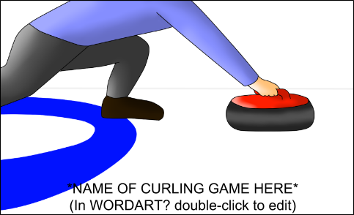

# Design details

* *More detailed description of how the game was designed and implemented including a complete class-diagram, description of the implemented classes etc.*

I vårt tidligere dokument skrev vi: “Our choice of architectural pattern for our game project will be a model/view/controller-design (MVC) to increase the modifiability of the game.” - men dette har vi ikke akkurat fulgt slavisk.

# User’s manual

* *Description of how to install, compile and run the game.*
* *Screenshots from the game describing how to play the game.*

The Android Application project zip file must be extracted to a chosen repository, opened with an IDE supporting Android development, and run on an emulator or your Android phone. After launching the application on a chosen device the user will be viewing the Main Menu of the game. By simply clicking on the Tutorial button on the Main Menu, the user will be introduced to the functions of the game and intuitively learn how to play it.

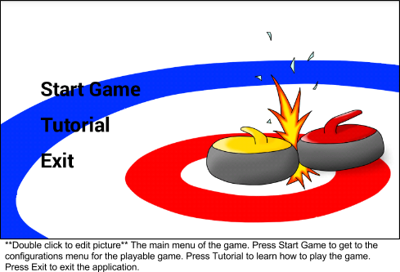

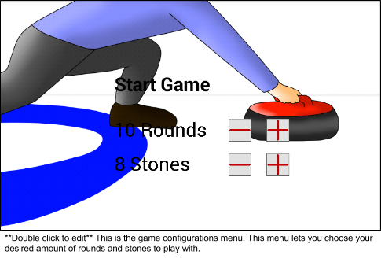

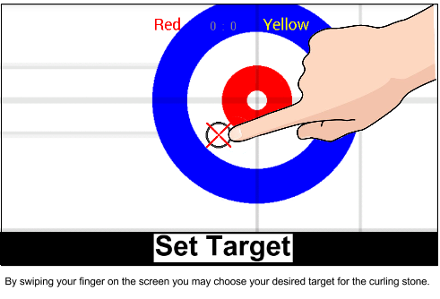

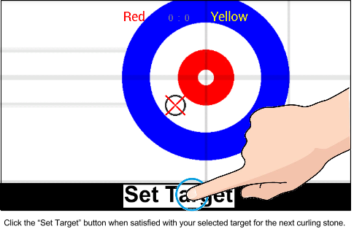

# Test report:

* Should contain test reports for both functional requirements and quality requirements (quality scenarios)
* Test reports must include IDs, description of the requirement, who did the test, date of test, time used, evaluation and comment about the result(s).
* Quality requirement test must in addition include stimuli, expected response measure and observed response measure.

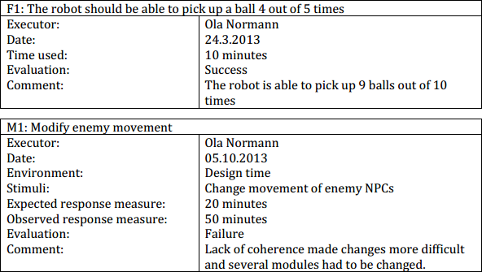

# 

# 

# 

# Relationship with the architecture

* List the inconsistencies between your architecture and the implementation. Give the reasons for these inconsistencies. Discuss whether they could have been discovered at an earlier point, for instance during the ATAM evaluation.

Foreløpig har vi ikke brukt patterns eller tactics som vi diskuterte før implementasjonsfasen.

# Problems, Issues and Points Learned

* In addition to listing problems and issues with the document or with the implementation process, this is also a spot to reflect upon the project and discuss what you would have done differently if you were to start again from scratch.

Lack of experience is still our main issue when implementing and applying an architecture to our android game application. It’s more dificult for us to estimate what architectures are the most efficient for a small game like this, as well as what patterns best compliment and are desired for the chosen architecture.